Safe Work Method Statement (SWMS)
COMPANY DETAILS  COMPANY NAME  ABN:  ADDRESS  PHONE: MOBILE:  FAX: |  | This SWMS has been developed and authorised by:
 |  | Name:
 |  | Position: |  | Date:
 |  | Signature: |  | Phone:
 |  | Signature: |  | Mobile:
Description of Work Activity: Working around moving plant and equipment
Trades involved with undertaking this work activity: Plumbers and apprentices
This SWMS is submitted to (principal contractor):
Company:
Contact Name: | Contact Name:
Site Address: | Project Description:
This SWMS is reviewed by (principal contractor):
Name: | Position:
Signature: | Date:
Phone Number: | Mobile Number:
Person responsible for supervising and implementing on this contractor’s behalf, the WHS controls associated with each step of this work activity:
Name:
Signature: | Date:
Phone Number: | Mobile Number:

Safe Work Method Statement – Powered Mobile Plant
Equipment Used: | Mobile Powered Plant  Description of plant to be used
Work Health Safety & Environmental Legislation | Work Health & Safety Act 2011  Work Health & Safety Regulation 2011 | Codes or Standards applicable to work | - Australian Standard 3500 National Plumbing and Draining  - Australian Standard 5601 Gas Installations  - Plumbing Code of Australia  - NSW Plumbing Act 2011 and Regulations 2017 (replacing the NSW Code of Practice for Plumbing and Drainage Regulation)  - NSW Code of practice for construction work  - Confined spaces  - Hazardous manual tasks  - How to manage and control asbestos in the workplace  - How to manage work health and safety risks Managing the risk of falls at workplaces  - How to safely remove asbestos  - Labelling of workplace hazardous chemicals Managing noise and preventing hearing loss at work Managing the work environment and facilities Preparation of safety data sheets for hazardous chemicals  - Work health and safety consultation, coordination and cooperation

COMPANY NAME
WHS MANAGEMENT SYSTEM
Date:

List plant, equipment and tools to be used | List hazardous substances to be used or handled | MSDS available? (Tick) | List PPE to be used |  | Tick | List hazards to consider | Tick
 |  |  |  | Hard Hat |  | Fall from ladder
 |  |  | 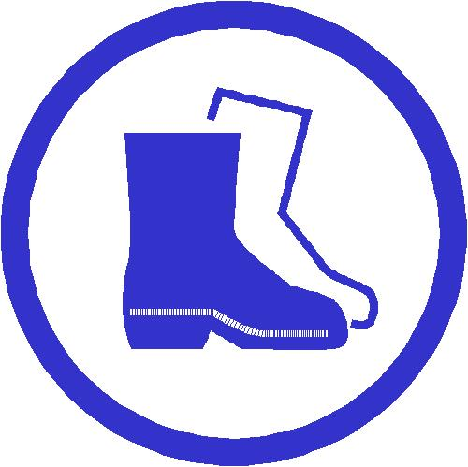 | Safety Footwear |  | Fall from heights
 |  |  |  | Eye Protection |  | Fall from scaffold
 |  |  | 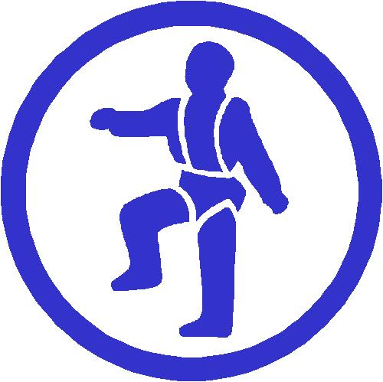 | Safety Harness |  | Contact with electricity
 |  |  | 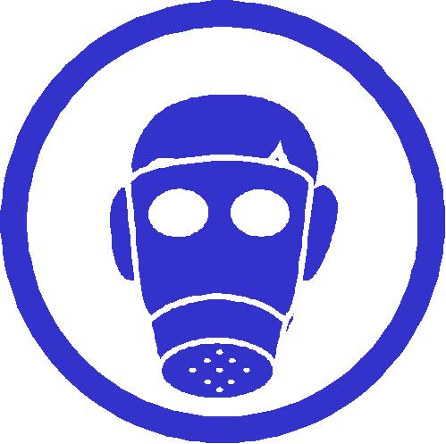 | Respiration Equipment |  | Falling objects
 |  |  | 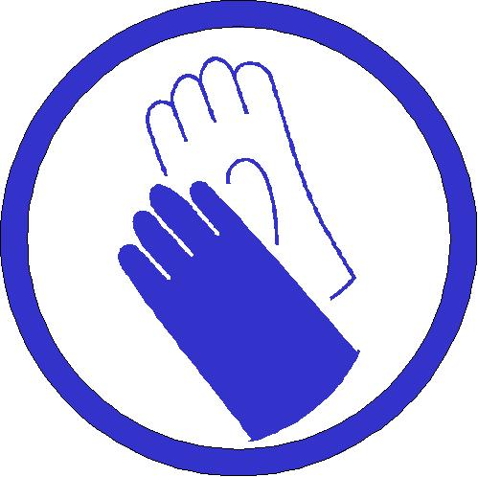 | Hand Protection |  | Collapse
 |  |  |  | Ear Protection |  | Slip, trips and falls
 |  |  | 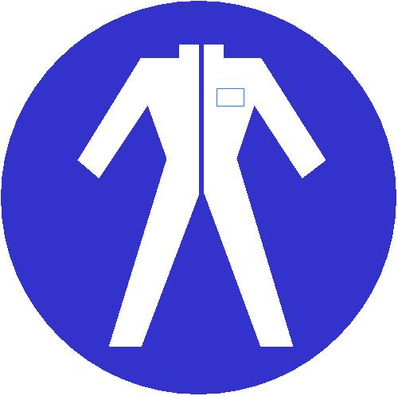 | Overalls |  | Manual Handling
 |  |  | 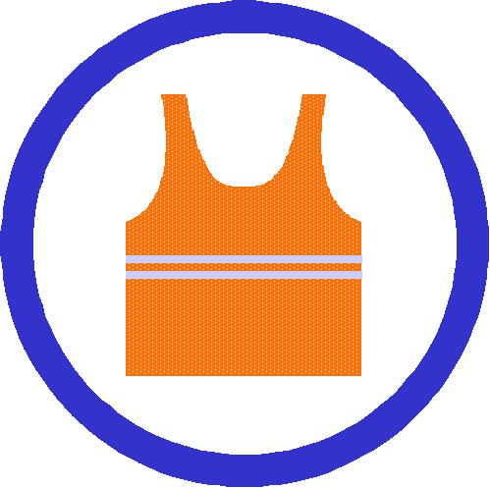 | Illuminating Safety Vest |  | Exposure to noise
 |  |  |  | Wet Weather Gear |  | Struck by moving plant
 |  |  |  | Sun Glasses |  | Inhalation of dust or fumes
 |  |  |  | Hat |  | Cuts
 |  |  |  | Sun Screen |  | Other (specify):
 |  |  |  | Other (specify):

Risk Scale Matrix
Review the risks involved and map them using the following scale and definitions.

 | How to complete the following form  - List the step-by-step sequence of tasks required to carry out a work activity from start to finish.  - List the potential hazards associated with each step, and the related WHS risks.  - Using the risk table, rate the identified risks.  - List what controls you will implement to reduce the risks to the lowest possible level.  - Rate the level of risk once those controls have been implemented (must be 4-6 before you can start work).  - List the names or positions of the persons responsible for ensuring that the controls are implemented.  A separate SWMS is required for each work activity.
  RISK TABLE |  | How likely is it to be serious?  NOTE: If a hazard is rated 1, 2 or 3, take action immediately.
  RISK TABLE | What damage could it cause? | Very likely  (could happen anytime) | Likely  (could happen sometimes) | Unlikely  (could happen, but only rarely) | Very unlikely  (could happen, but probably never will)
  RISK TABLE | Death or permanent disability | 1 | 1 | 2 | 3
  RISK TABLE | Long term illness or serious injury | 1 | 2 | 3 | 4
  RISK TABLE | Medical attention and several days off work | 2 | 3 | 4 | 5
  RISK TABLE | First aid needed | 3 | 4 | 5 | 6

Work Method Statement
Activity: Working in an area where there is movement or use of powered mobile plant

Activity steps  Break the activity down into steps. List the steps in this column. | Hazards identification  Identify any potential hazards associated with each step – and any related risks. Detail the hazards and risks in this column and enter the risk rating in the next column. | Initial risk rating (1-6) | Controls to be implemented  Decide what controls to use to eliminate or minimise the risks. Detail the controls in this column, and enter the revised risk rating in the next column. Note: If the risk rating is still 1-3, do not begin work | Revised risk rating (1-6) | Person Responsible
1. Issue PPE | - Head, hand, foot, eye or body injuries | 2 | - Ensure all site personal have received and signed for all relevant PPE and know how to fit and use it. | 6
2. Establishment of Site | - Workers struck by moving mobile plant  - Slips/Trips/Falls  - Manual Handling  - Noise | 3 | - Ensure traffic Management Plan is prepared and consult with workers  - Exclusion zones to be set out and clearly identified.  - Hi –visibility clothing to be worn  - Correct manual handling techniques to be followed.  - All workers are to wear earmuffs/earplugs when working in vicinity of noisy plant  - All workers are to be secured within plant in accordance with manufacturers guidelines | 6
3. Concrete trucks entering site and concrete pumping.  Traffic entering site for delivery of materials | - Workers struck by moving mobile plant  - Slips/Trips/Falls  - Manual Handling | 3 | - Ensure traffic Management Plan is prepared and consult with workers  - Exclusion zones to be set out and clearly identified.  - Barricade work area.  - Hi –visibility clothing to be worn  - Correct manual handling techniques to be followed when unloading.  - Unload in designated areas.  - Avoid unnecessary unloading by ensuring materials are delivered to correct area. | 6

Activity steps  Break the activity down into steps. List the steps in this column. | Hazards identification  Identify any potential hazards associated with each step – and any related risks. Detail the hazards and risks in this column and enter the risk rating in the next column. | Initial risk rating (1-6) | Controls to be implemented  Decide what controls to use to eliminate or minimise the risks. Detail the controls in this column, and enter the revised risk rating in the next column. Note: If the risk rating is still 1-3, do not begin work | Revised risk rating (1-6) | Person Responsible
4. Forklifts  Material Movement | - Workers struck by moving mobile plant  - Slips/Trips/Falls  - Manual Handling | 3 | - Ensure traffic Management Plan is prepared and consult with workers  - Exclusion zones to be set out and clearly identified.  - Hi –visibility clothing to be worn  - Correct manual handling techniques to be followed when unloading.  - Unload in designated areas.  - Avoid unnecessary unloading by ensuring materials are delivered to correct area. | 6
5. Elevated Work Platforms or  Scissor Lifts | - Workers struck by moving mobile plant  - Falls from machinery  - Contact with overhead power lines | 3 | - Exclusion zones to be set out and power clearly identified.  - Barricade area.  - Ensure operator has relevant permit to operate machinery.  - Carry out all pre-inspection checklists and check log books.  - Consult with workers on EWP Rescue Plan  - Correct manual handling techniques to be followed. | 6
6. Overhead Cranes | - Workers struck by moving mobile plant  - Contact with overhead power lines  - Objects Falling | 1 | - Exclusion zones to be set out and clearly identified.  - Work within safe distance of overhead power lines as published by the local supply authority  - Hi –visibility clothing to be worn | 6

Special notes: (add issues identified which may need to be further discussed during the review stage)

Safe Work Method Statement (Part 2)
Personal Qualifications and Experience: | Personnel, Duties and Responsibilities: |  | Training Required to Complete Work:
Plumbing Tradesmen | Work under supervision of site foreman |  | Ongoing safety training by way of Tool Box Meetings
Plumbing Apprentices | Work under direct supervision of tradesman |  | Ongoing safety training by way of Tool Box Meetings
Mobile equipment licenses | None applicable |  | All workers operating equipment to have undergone formal training
Engineering Details/Certificates/WorkCover Approvals: |  | Codes of Practice, Legislation:
 |  | Refer to form on page 2.
Plant/Equipment: |  | Maintenance Checks:
 |  | In accordance with manufacturer’s requirements
Read & Signed by All Employees on Site: Refer to attached register

ANY OTHER REQUIREMENTS ETC

Number | Requirements | Action

Declaration by contractors and workers |  |  | Yes No
I have been consulted and have assisted in the development of this SWMS.
I have been given the opportunity to comment o the content of this SWMS.
I have read and understand how I am to carry out the activities listed in this SWMS.
I have been supplied with the Personal Protective Equipment identified on this SWMS and I have been given training in the safe use of this equipment.
I have read and understand the requirements set out in the Material Safety Data Sheets for the Hazardous Substances identified in this SWMS
Name | Signature | Date

The SWMS template has been developed through consultation with our workers and has been read, understood and signed by all workers undertaking the works:
Print Names: | Signatures: | Dates:

Review No | 01 | 02 | 03 | 04 | 05 | 06 | 07 | 08 | 09
Initial:
Date:

